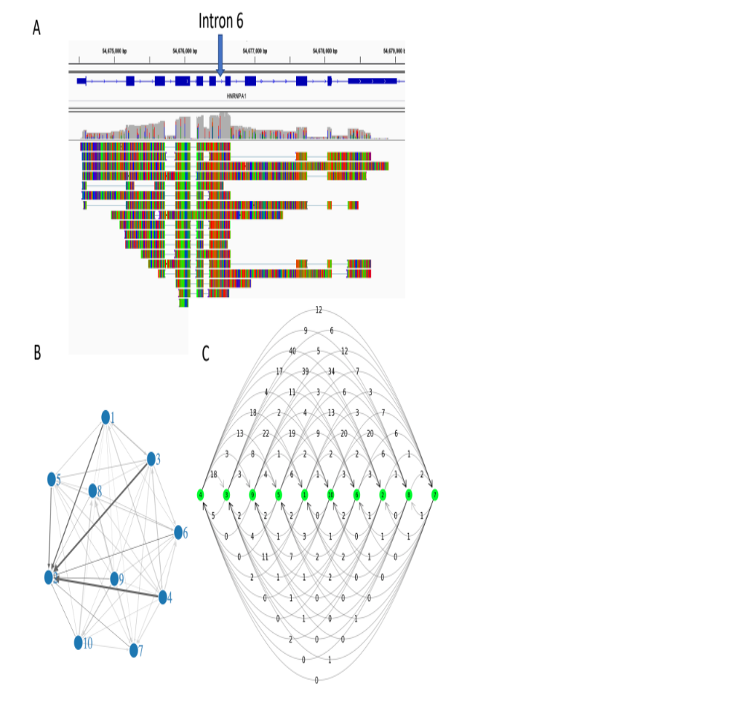
Supplementary Figure 1. Intron splicing order of hnRNP A1. A) IGV snapshot of reads that support intron 6 spliced slower than other introns. The relative intron splicing orders in this figure are used to fill the column 6 of the read count matrix. B) The intron splicing order read count graph of hnRNP A1. The intron index number is labeled in the vertex, and arrow from 1 to 2 means intron 1 spliced before intron 2. The width of the arrow line represents the read count supports this intron splicing order pair. C) Reorder the intron splicing order read count graph by most likely order, arrows above the vertexes point to the last spliced introns, arrows below the vertexes point to the first spliced introns. The values above the vertexes larger than the values below the vertexes, this supports the most likely order calculated.
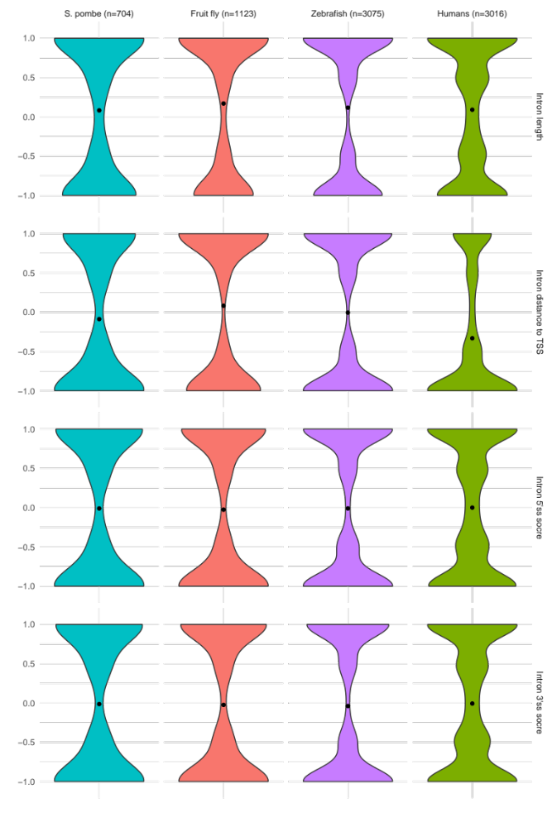
Supplementary Figure 2. Correlation of most likely orders with introns’ length, introns’ distance to TSS, 5’ splice site maxEntScore and 3’ splice site maxEntScore in S. pombe, fruit fly, zebrafish and humans respectively.
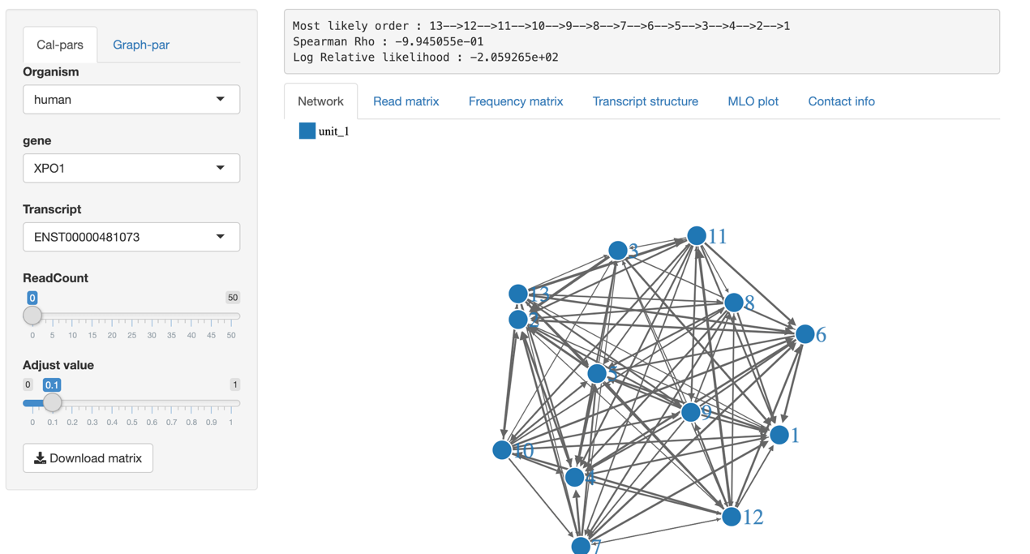
Supplementary Figure 3. Website snapshot.
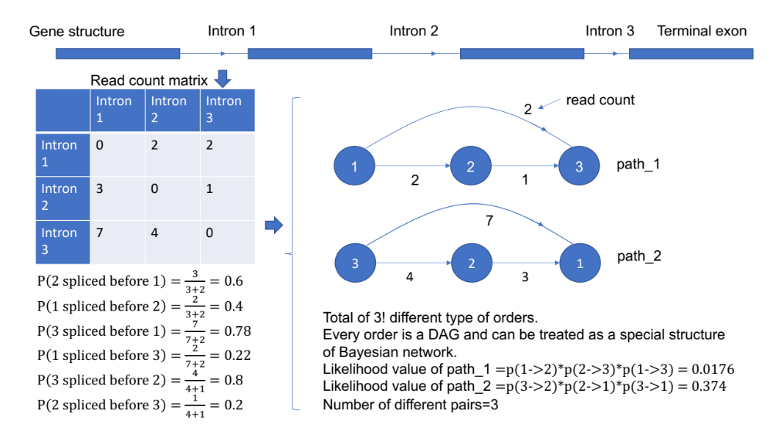
Supplementary Figure 4. An example of how to calculate the likelihood values for each type of order.

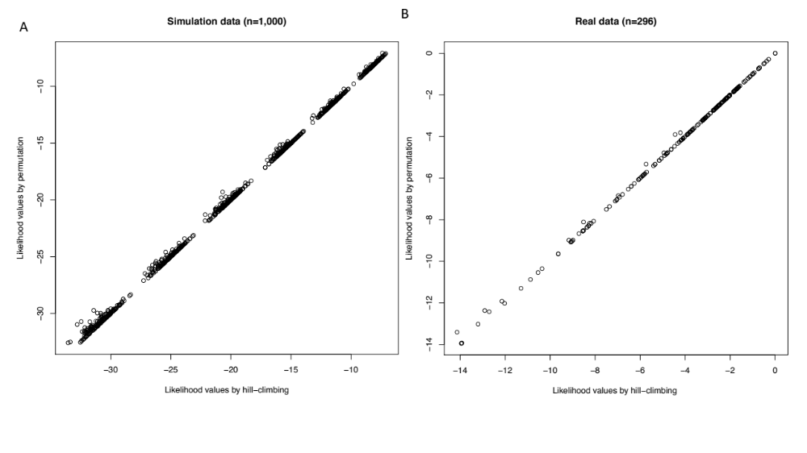
Supplementary Figure 5. A) Comparing calculated likelihood values by permutation and hill-climbing in a total of 1,000 times for transcripts that contain 6~11 introns. The read count matrixes were simulated total randomly using Poisson distribution. B) Comparing calculated likelihood values by permutation and hill-climbing using real read count matrixes in humans, only transcripts that contain 6~11 introns are used.
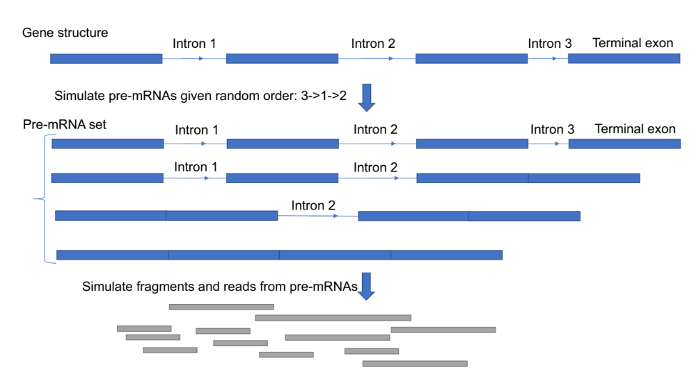
Supplementary Figure 6. A diagram of how I simulate fragments and reads from pre-mRNA given defined order.

